## Partner contact info

Organization: Erste Yazılım

Type: Industry/SME/Research/Academia

Name: Özer Aydemir

E-mail: ozer@iotiq.de

Phone #:

## Partner interests within the project

<Please provide a short description of your R&D and collaboration interests and expectations within the OWE4SC project>

Erste, established in Cyberpark Bilkent , Ankara in 2007 , is R&D based multinational SME collaborated with corporates and companies( Bosch, Siemens, Koç sistem etc. ) .Our mainly focuses are IOT technologies and advancements ,video streaming and analysis as wells as mobile applications and framework development. We also bid for state-of-the-art software development projects and will be part of the research project consortia across Europe. Our purpose is mainly to offer a good quality end to end services for our customers and partners. Our projects got awarded several times by respective committees for instance TUBİTAK, KOSGEB and ITEA etc... We use the latest and most advanced technologies (such as JavaScript, NodeJS, ExpressJS, MongoDB, Wowza etc... ) to satisfy our clients’ expectations from a variety of domains(such as Supply chain, Infrastructure, Health, Energy etc.) and to increase our services quality. We actively participate in Cluster programs such as ITEA3, EUREKA etc. including innovative, industry driven and pre-competitive R&D projects with the purpose of gaining know-how and reinforcing our skills.

## Open Data and Technologies

We have an ongoing project such as Gamma developed in context of smart building and areas that might linked to OWE4SC. Gamma , is a collaborative and enriched platform to create most convenient and comfortable environment for our client by incorporating heterogeneous network and devices(such as HVAC, electricity and water etc). Our project relies on distributed control mechanism to provision device to device communication instead of centralized management by reducing number of manual operations, it also mitigates the risks of unexpected events and outages in an reliable, secure and interoperable and loosely coupled way. Link given below describes project details and description.

<http://gammaf.herokuapp.com/#/>

## Success Factors/KPIs

<Please describe when you would see the project has been a success for you. Please identify and list relevant KPIs (Key Performance Indicators) from your organizations viewpoint.>

* Accuracy and precision of methodologies and algorithm (To be specified after SotA analysis).
* The minimization of network faults (latency and low-bandwith problems etc. The details will be shared after SotA analysis)
* Establishing reliable and quick communication among devices in real time (To be specified after SotA analysis a). (To be specified after SotA analysis).
* Fast and reliable system recovery and back-up without human based operation (measurement will be decided after SotA analysis).

## Background

Please list previous R&D projects you see relevant regarding OWE4SC project as background/collaboration possibility:

|  |  |  |  |  |
| --- | --- | --- | --- | --- |
| Project Name | Cooperative Programme | Time period (approx.) | Technical Focus | Relationship |
| <BaaS > | <ITEA3> | <2012> | < The main basis of Baas is technological production focused on smart buildings and smart environment with IOT technologies. Within this project,  Baas aims to build integrated services on the environment to eliminate time or operation related problems and risks. All objects and devices in the place thus sensors, actuators and device) s can communicate each other more seamlessly, secure and feasible wıthout interruption. 2D environment envıronment and building modelling, layering and commissioning are one of the features adding the values in the system architecture and framework platform  > | OWE4S project can be categorized as extended version of Baas bywıth AI and machine learning based methodologies(such as Machine to machine communication, providing integrated and seamless platform, product lifecycle management tool( 3D modelling , supervisioning commissioning and layering of buildings and environment ) OWE4S can cover some parts being similar to Baas  Project( for example . |
| Optimum | ITEA | 10.2017-- | Within OPTIMUM project, we'll help the consortium to build an IoT platform for implementing Industry 4.0 to the material handling means.  Optimum technical focus is to develop IIOT based open-source and distributed platform providing machine to machine communication by eliminating manual operations complexity All cranes in the system will have their self-control mechanism and exchange their information and data based on distributed control application by context-awareness methodologies and localization systems  Also  3D-based engineering, virtual commissioning and supervision based on common models is one of the feature to add values in the system . | OPTIMUM might be directly linked to OWE4S with respect to entities mentioned below  Replacing centralized control of manufacturing and material handling components by intelligent components based on distributed control software(even on the sensors),  Enhancing control SW of material handling components with context awareness,  Replacement of HW diversity by SW modularity,  Design of an open platform supporting interoperability with third-party control and application software,  Increasing safety, performance and flexibility based on context/ awareness and secure communication between distributed control modules,  3D-based engineering, virtual commissioning and supervision based on common models. |

Please indicate any relevant publications (scientific papers, white papers, etc), which you see relevant for the OWE4SC project as background information:

* Medagliani, Paolo & Leguay, Jeremie & Duda, A & Rousseau, Franck & Duquennoy, Simon & Raza, Shahid & Ferrari, Gianluigi & Gonizzi, Pietro & Cirani, Simone & Veltri, L & Montón, Màrius & Domingo Prieto, Marc & Dohler, M & Villajosana, I & Dupont, O. (2014). Internet of Things Applications - From Research and Innovation to Market Deployment.
* Muhammad Rizwan Anawar , 1 Shangguang Wang , 1 Muhammad Azam Zia,2 Ahmer Khan Jadoon,1 Umair Akram,3 and Salman Raza1 Fog Computing: An Overview of Big IoT Data Analytics

Please indicate any relevant market study you see relevant for the OWE4SC project objectives:

* [https://www.mckinsey.com/~/media/mckinsey/industries/capital%20projects%20and%20infrastructure/our%20insights/voices%20on%20infrastructure%20turning%20the%20smart%20city%20opportunity%20into%20reality/voices-december-2017-web.ashx](https://www.mckinsey.com/~/media/mckinsey/industries/capital%20projects%20and%20infrastructure/our%20insights/voices%20on%20infrastructure%20turning%20the%20smart%20city%20opportunity%20into%20reality/voices-december-2017-web.ashx%20)
* <https://ww2.frost.com/files/8715/1248/3558/SmartCities_-_Nov_2017.pdf>
* <https://www.forbes.com/sites/bernardmarr/2018/01/28/blockchain-and-the-internet-of-things-4-important-benefits-of-combining-these-two-mega-trends/#4c074dfd19e7>
* https://www.buildingtechnologies.siemens.com/bt/global/en/building-solutions/bps/strategy-planning/advantage-navigator/Pages/advantage-navigator.aspx

## Collaboration

<Please describe what kind of collaboration and networking benefits and added value your organization is looking for by participating the project. Please consider both business and technological viewpoint.>

Outputs<Please describe outputs (novel algorithms, standards, open source libraries, implemented collaborative framework, demonstrator, product prototype, new service based on some software, wearable device, etc.) that you organization can create/contribute to during the project.

* Unsupervised learning methodologies
* Semi –supervised learning techniques
* Distributed control platforms
* Creating analytical and statistical based dashboards
* 2D or 3D modelling supervisioning and commissioning based platform
* Smart environment based platforms
* Distributed control platform
* Mobile device management based systems
* Video and media streaming , capturing based systems
* DOME(Distributed object modelling environment)
* Security frameworks and application STRIDE analysis
* Open source based mobile applications
* Image and Video blurring algorithms
* Engineering tools for enhanced smart evironments

## Role of the partner

## Through OWE4SC project lifecycle first we can gather and analyze requirement by talking and discussing with stakeholders and end users in the service of WP2, Wp3 and WP4 related task execution. .Also, we would like to join the tasks concerning development edge computing technologies, Internet of Things (IoT) development and digital infrastructure construction in WP4 iunder the scope of edge computing markets. We can participate in proof of concepts studies and develop demonstrator over the top of applicatio and frameworks to test their eligbilities and performances tied to digital marketing services.

## Innovations and Standards

<Please list any relevant innovations and standards regarding the project from you organization perspective. Please identify any relevant standardization organizations that your organization is participating.>

## Value chain positioning

<Please describe positioning of your organization in socio-cyber-physical value stream and markets illustrated in Figure 1 below>

**Relevant markets of the socio-cyber-physical value stream for my organization:**

Our organization actively participate in IOT based project and some of them (Gamma and Mobivisor and Bey) have already commercialized. Along these projects mentioned before, we gained insight and perspective about how new technologies and methodologies can be applied for diverse variety of domain(smart energy, environment, supply chain) .Generally , we mainly focused on the following areas such as edge computing technologies and systems, application and frameworks development, video and media streaming, brokerage, image processing, mobile applications and APIs and security frameworks. Within given context, our market position can be placed in:

* Edge Computing Markets
* Autonomic system markets
* Professional mobile apps and services markets

**Positioning in the socio-cyber-physical value stream:**

<Please describe the added value your organization can bring within the value stream. What kind of organizations you envision as customers for your offering and on which markets? Which markets you need to participate and what kind of organizations you need to co-operate with to be able to provide your envisioned offering?>

Since the beginning of April 2018 World Bank dedicated $91.54 million budget for the Sustainable Cities II Project in Turkey. With this funding, economic, societal, financial and environmental condition will be fostered by providing enhanced services to municipalities in the cities. Generally the some part of the budget was spent on construction renewal, water and wastewater systems. Also semi government companies like Turk Telekom and Innova has broadband fiber infrastructure in every city in Turkey, it could act as an integrator for U.S. companies while reaching out to Turkish municipalities.

With technological advancement and increase in people demand and interest, the market share of smart environment has grown especially among construction companies. According to given surveys in Turkey, using smart technologies in municipalities has been increased by 47%. In global era, at least 80% of construction will include at least one IOT based technologies. According to given results, global IOT smart building market will reach 51,44B$ globally by 2023. At least 33% of buildings and constructions will be advanced with AI based technologies. 5G and real time data analytics accompanied with IOT will play major roles in smart building systems.

Our target audience would consist of IOT companies, smart building companies, telecom infrastructure supplies, cloud services and management. Our solution will address for the divisions mentioned below:

* Smart Buildings Manufacturers
* Smart Buildings Distributors/Traders/Wholesalers
* Smart Buildings Subcomponent Manufacturers
* Industry Association
* Downstream Vendors

Using smart technologies in the cities and buildings contributes to economic growth and social impact in terms of the subjects mentioned below:

1. The global business network will be extended. Our production can motivate other groups to carry out more research and development based projects. Municipalities can be motivated to allocate more budgets on smart technologies and IOT based applications.
2. The interest rate of people working in construction and trading companies can increase against AI- and machine learning based systems.
3. Adding smart features in buildings will make people’s life easier and comfortable, as well as the security and safety in the environment can be ensured leading to increase their life span.

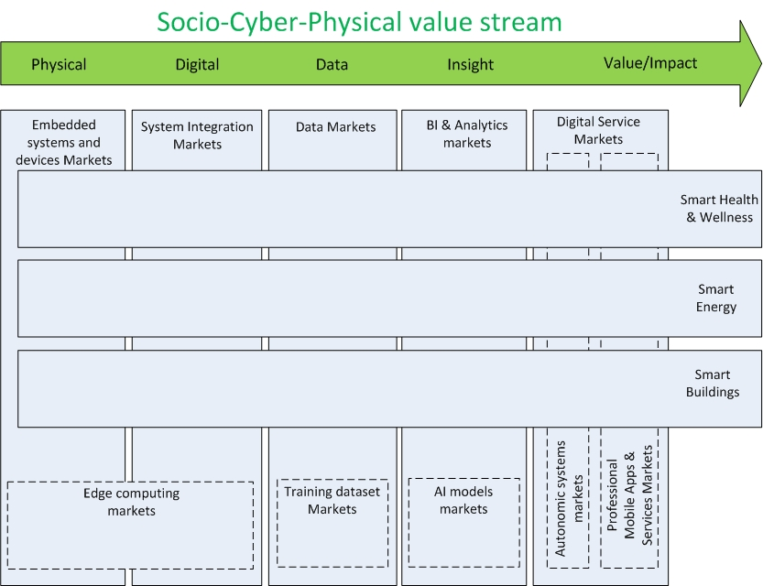

**Figure 1. Socio-Cyber-Physical value stream, related markets and application domains**.